**Methods of Polymerisation: -** It is the process by which simple (monomer) molecules join together to form very large (polymer) molecules.

The polymerisation is of two types: 1. Homogeneous

* 1. Heterogeneous

Homogeneous polymerization: In homogeneous polymerization, only one phase is involved.

Heterogeneous polymerization: In heterogeneous polymerization, more than one phase is involved.

Heterogeneous polymerization is of two types: 1. Emulsion

2. Suspension

# Emulsion polymerisation:

In emulsion polymerization, the monomer is added as fine droplets in an aqueous phase, which is stabilised by adding a surfactant (soap or detergent). The surfactant will form a micelle containing a dissolved monomer. Later, a water-soluble initiator (like hydrogen peroxide or persulfate) is added, which diffuses into the micelle-containing monomer molecules. Polymerization will start and more monomers will migrate into micelles. The size of the micelle increases due to the formation of the polymer. Polymerization is terminated when a new radical, like an electrolyte, diffuses into the micelle.

This method is used to prepare polymers that are of high molecular weight and contain water-insoluble monomers. It is the most commonly used in industries for the manufacturing of water-based paints or adhesives containing monomers such as styrene, vinyl acetate, or vinyl chloride.

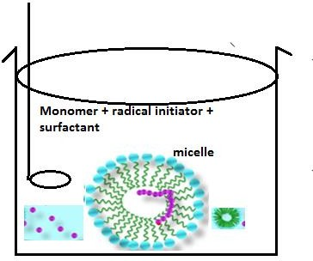

# Fig 1.1: Emulsion Polymerisation

**Advantages:**

* + - 1. A high molecular weight polymer is obtained.
      2. High polymerization rates.
      3. A medium-viscosity polymer is obtained.

# Disadvantages:

1. Surfactant is difficult to remove.
2. Water removal is tough.

# 1.2.2 Suspension polymerisation:

In this method, the monomer is dispersed as large droplets in water and is kept in suspension by mechanical agitation using stabilizers such as gelatine or water-soluble cellulose derivatives. The initiator used remains soluble in the monomer, which initiates polymerisation in each droplet. The polymer is obtained as spherical beads. This technique is cheap as it involves water as a solvent. This method is limited to water-insoluble monomers such as vinyl chloride, vinyl acetate and styrene.

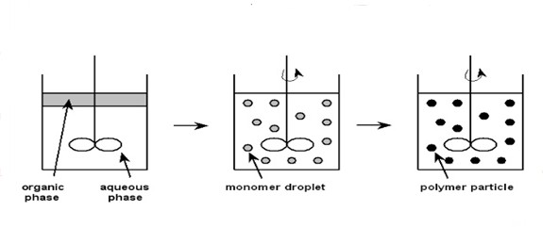

# Fig 1.2: Suspension Polymerisation Advantages:

1. This method is cheap.
2. The heat of polymerization is absorbed by water.
3. The product is in the form of beads.

# Disadvantages:

1. The purity of the sample is low.
2. Polymers cannot be isolated easily.